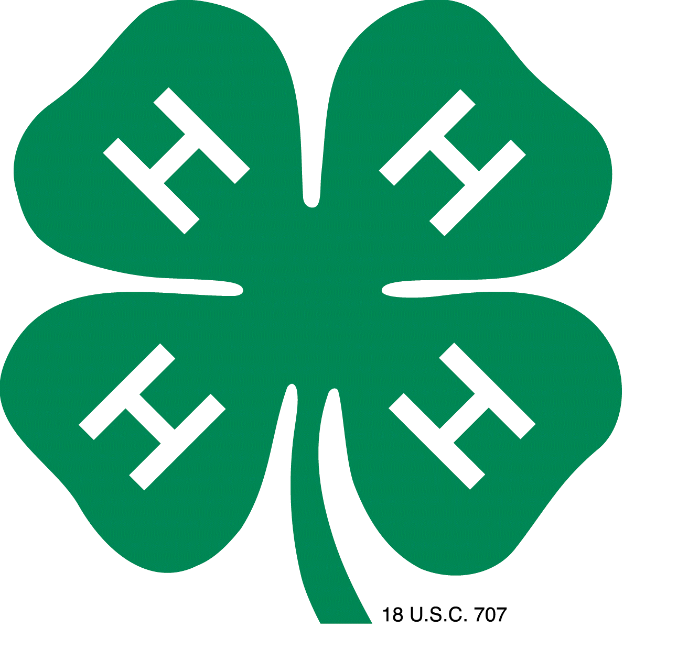
Kansas
Salute to excellence 2019
Volunteer RECOGNITION awards
Nomination form

4-H is a community of young people across Kansas who are learning leadership, citizenship and life skills. Volunteers are the heartbeat of the 4-H program serving as mentors, teachers and friends. The National Salute to Excellence Volunteer Recognition Award recognizes 4-H volunteers who demonstrate exceptional service to 4-H. The Kansas Association 4-H Volunteers has adopted the Salute to Excellence award to recognize and promote Kansas 4-H volunteers who have excelled in their roles locally and continue with selecting Kansas’ top volunteers for National competition. The Kansas Association of Volunteers believes establishing the Salute to Excellence Award will provide two options for the Kansas 4-H Program: 1) recognition of 4-H Volunteers for their outstanding contributions to 4-H youth and 2) enhance the mission and awareness of the Kansas Association of 4-H Volunteers.

Each extension unit will select their representative and submit their nominees electronically to the Department of 4-H Youth Development by December 3, 2018. These individuals then will have an opportunity to be selected as the Kansas Outstanding Lifetime Volunteer and Volunteer of the Year. The two Kansas honorees then become Kansas’ nominees for the North Central and National award.

I. Award Criteria
- The Volunteer of the Year Award is for individuals who have served as 4-H volunteers for less than 10 years at the local, county, district or state level as determined before January 1, current year.
- The Outstanding Lifetime Volunteer Award is for individuals who have served 10 or more years at the local, county, district or state level as determined before January 1, current year.
II. Nomination Procedures
- Nomination Packets must be submitted to the County Extension Agent by Nov. 23rd.
- A completed nomination will consist of a nomination resume of the applicant’s 4-H and relevant community volunteer experiences and three (3) letters of recommendation. Please use the enclosed template when developing the nomination packet. A packet missing any of the four components (resume and 3 letters of recommendation) will be eliminated.
- Letters of recommendation must be no longer than 2 pages in length, in 12-point font with 1-inch margins. Letters of Recommendation should be written by individuals who can best describe the nominee’s qualifications for the award such as a 4-H youth participant, another volunteer, etc.
- Nominations/letters of recommendation must address the following selection criteria:

Positive impact the nominee has on 4-H and on 4-H youth

Nominee’s ability to work with young people on projects and activities in a way that promotes decision-making, problem-solving, meeting challenges, mastery and youth/adult partnerships

Nominee’s innovative approaches to engaging youth and increasing diversity among participants
- How nominee exemplifies a “mentor-learner” relationship with participants
- Dedication to a safe and inclusive environment
- How nominee models character and professional behavior when interacting with participants, families, and community partners

Nominee’s innovative approaches to performing volunteer service

Increased funding/resources generated by nominee
- Recruitment of additional 4-H volunteers
- Personal growth from being a 4-H volunteer (that you have observed)
- Letter writers should be aware of the scorecard and address the relevant points in developing their word documents.

Award Information
- County/District Offices establish deadline for local application.
- Local applications due to the Department of 4-H Youth Development, December 3. 2018 in word document.
- Kansas Salute to Excellence recipients recognized at Emerald Circle Banquet. Honoree will receive a plaque.
- North Central Regional winner announced 2019. The North Central recipient will receive $200 in the Honoree’s name to a local 4-H Program of the Honoree’s choice.
- Regional winners announced during the fall 2019.
- National winners announced during National Volunteer Week, 2019.
- National winners recognized at the 4-H Center in Chevy Chase, MD, 2019.
- Awardees should be prepared to provide information in subsequent years regarding the impact of their awards on their community.

Volunteer RECOGNITION awards
Application Template

Application Guidelines: (County/Districts may determine to participate)
- Application materials must be submitted electronically in a Word Document (do not put in pdf format) by the nominator to the local Extension Office. Each County/District (one for each county represented) Extension Office will select one nominee for each category.
- Each completed application must be accompanied by three letters of recommendation. Letters of recommendation must be written by a 4-H staff member, 4-H youth participant, another volunteer, or a parent/guardian. Letters should be no longer than 2 pages in length, in 12-point font with 1-inch margins.
- A resume of 4-H experiences and community service must be included and should follow the template provided. It is limited to 3 pages in length, in 12-font with a one-inch margin.

Nomination for (check one):
󠄾 Outstanding Lifetime Volunteer (10 or more years of service to 4-H)
󠄾 Volunteer of the Year (less than 10 years of service to 4-H)

Please include a high quality, 600dpi headshot of the nominee. If selected, nominee’s photo, name, state and 4-H highlights will be posted on the 4-H website.

Application must include:

Name:
Street address:
Post Office, State, zip code
Email:
County, State

- Brief overview of why the nominee deserves this award (500 words or less):

- Evidence of a positive impact on the lives of 4-H youth:

- Demonstrated ability to work with young people in a way that promotes youth empowerment, decision-making, problem-solving, meeting challenges, and mastery.

- Nominee’s dedication to youth/adult partnerships and developing mentor-learner relationships.

C. Evidence of a positive impact on the 4-H program:

- Nominee’s innovative approaches to engaging new youth and increasing diversity among participants.

- Dedication to providing a safe and inclusive environment for youth.

- Nominee’s innovative approaches to performing volunteer service, recruitment of additional 4-H volunteers, partnering with other youth serving agencies, fundraising, providing other resources for 4-H, advocacy for 4-H, etc.
D. Personal attributes:

- Evidence of professional attitude, character, and morals.

- Personal growth from being a 4-H volunteer (that you have observed).

E. Personal involvement in 4-H:

- List local 4-H roles (4-H Project Leader; Community 4-H Club Leader, etc.). Include summary of years, roles, and organizations.

- List County (Parish)/District 4-H roles (County Extension Committee, etc.). Include summary of years, roles, and organizations.

- List State/Regional/National 4-H roles (Regional 4-H Volunteer Leader Forum Planning Committee, etc.). Include summary of years, roles, and organizations.

- List relevant 4-H honors/awards and years received.

- List relevant non-4-H volunteer roles. Include a summary of years, roles, and organizations.

F. Optional – FOR ADDITIONAL INFORMATIONAL PURPOSES ONLY

- If nominee was involved in 4-H as a young person, please indicate the state where nominee was involved, type of involvement (4-H projects taken, 4-H camper, etc.), years of membership, exemplary awards, leadership roles, etc.

- Current position (professional/homemaker). If retired, most recent role.

INCOMPLETE OR INAPPROPRIATE FORMATTED APPLICATIONS WILL BE DISQUALIFIED

WORD Document do NOT put in pdf format

